**ASSIGNMENT-8**

SHUBHAM HOSALIKAR -PES1201701501

NAMAN BATRA -PES1201701120

PULLEH BHATIA -PES1201700111

JASRAJ ANAND - PES1201700171

**PROBLEM STATEMENT : Decision Tree Classification** 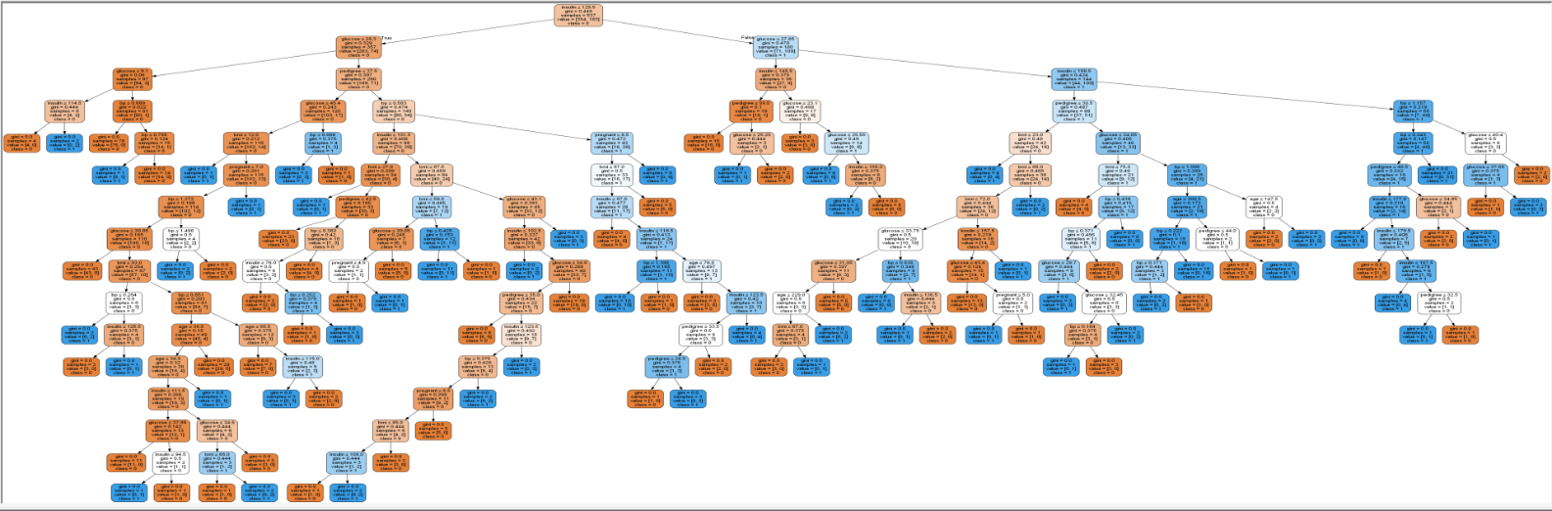

Accuracy: 0.670995670996

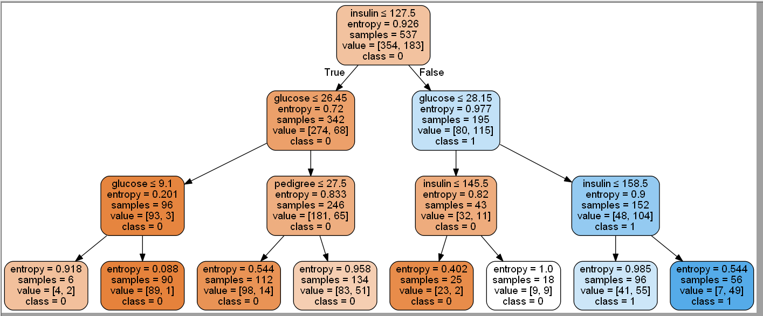

Accuracy: 0.770562770563